**DOCUMENTATION**



**TOPIC : FOOD TREND ANALYSIS**

Customer Analysis Dashboard



**SUBMITTED TO : NITHYASRI S J**

**SUBMITTED BY: LEKSHMI R**

**INDEX**

|  |  |  |
| --- | --- | --- |
| **S.no.** | **Title** | **Page no.** |
| **1** | **ABSTRACT** | **3** |
| **2** | **INTRODUCTION** | **4** |
| **3** | **OBJECTIVES** | **5-6** |
| **4** | **PROBLEM STATEMENT** | **6-7** |
| **5** | **SCOPE** | **7-8** |
| **6** | **DATASET DESCRIPTION** | **9-11** |
| **7** | **DASHBOARD DESCRIPTION** | **11-20** |
| **8** | **TECHNOLOGY USED** | **20-23** |
| **9** | **METHODOLOGY** | **24-31** |
| **10** | **KEY INSIGHTS** | **31-34** |
| **11** | **CONCLUSION** | **34-37** |

**ABSTRACT**

This study presents a comprehensive analysis of customer preferences and trends in the Food & Beverage (F&B) industry, using an interactive Power BI dashboard developed on a synthetic yet realistic dataset of approximately 4,500 orders and 22 features. The objective is to uncover patterns related to customer demographics, cuisine popularity, ordering behaviour, platform performance, regional differences, and seasonal fluctuations. The dashboard comprises a home page and six analytical pages: Customer Demographics & Preferences, Product & Menu Insights, Ordering Behaviour & Customer Satisfaction, Regional & Platform Insights, Seasonal & Time-Based Trends, and Future Insights & Recommendations.

Key findings demonstrate that younger customers (18–30) contribute the largest share of online orders; fast food and desserts are high-volume categories; Zomato accounts for a significant portion of orders; wallet and UPI payments dominate urban areas; desserts peak during summer months; and delivery time strongly correlates with customer ratings. Forecasting analysis indicates potential revenue uplift through targeted promotions and category-focused marketing. The report further outlines methodology, detailed visualization design, DAX calculations, business implications, limitations, and future enhancements.

**INTRODUCTION**

The Food and Beverage (F&B) industry has undergone a massive transformation in recent years due to technological advancements, changing lifestyles, and evolving consumer preferences. The traditional dining-out culture has been significantly influenced by the growing presence of online food delivery platforms, digital payment systems, and data-driven decision-making in restaurant operations. With rapid urbanization, a busy workforce, and the increasing accessibility of smartphones, customers today have access to a wide variety of cuisines and food choices at their fingertips. Understanding how these customers make decisions what they order, when they order, and from where is crucial for any food business to stay competitive.

The rise of data analytics tools such as Power BI has allowed organizations to analyse large volumes of customer and sales data to identify trends, optimize menus, manage inventories, and enhance customer satisfaction. Through data visualization and business intelligence, companies can uncover patterns such as seasonal demand fluctuations, platform-based order differences (like Swiggy vs. Zomato), regional taste preferences, and customer satisfaction levels based on ratings and delivery time.

This project, *“Food Trends: Understanding Customer Preferences in the F&B Sector”*, leverages a comprehensive dataset of customer orders, including demographic details, product categories, purchase behaviour, payment modes, and delivery platforms. By analysing this dataset, the team aims to generate insights that can help restaurants, food aggregators, and other F&B stakeholders understand consumer behaviour, identify opportunities for growth, and make data-driven business decisions.

**OBJECTIVES**

The main goal of this project is to explore and visualize customer preferences in the food and beverage sector through a data-driven approach using Power BI. The project aims to transform raw data into clear and actionable insights that can guide decision-making in various dimensions of the food industry.

**Specific objectives include:**

1. **To analyse customer demographics and preferences**

Understand how factors like age, gender, region, and income influence food ordering behaviour and category choices.

1. **To identify product and category trends**

Determine which food categories (e.g., Fast Food, Desserts, Beverages) dominate orders and how their demand fluctuates across time.

1. **To study order patterns and customer satisfaction**

Examine how ratings, delivery times, and order frequency are related to satisfaction levels and repeat purchases.

1. **To analyse platform-based performance**

Compare the performance of major food delivery platforms (Swiggy, Zomato, etc.) in terms of orders, ratings, and revenue contribution.

1. **To study regional and seasonal variations**

Identify how customer demand differs across cities and seasons (summer, winter, monsoon), revealing local preferences and peak sales periods.

1. **To forecast future food trends**

Use Power BI’s predictive capabilities to estimate future sales or order patterns and suggest potential business opportunities.

1. **To develop a comprehensive, interactive Power BI dashboard**

Design a visually appealing, data-rich, and interactive dashboard that serves as a complete analytical and reporting solution for the F&B sector.

1. **To provide data-driven business recommendations**

Conclude with actionable insights and strategies that businesses can adopt to enhance customer experience, operational efficiency, and profitability.

**PROBLEM STATEMENT**

In the competitive and dynamic F&B market, businesses struggle to keep up with continuously changing customer demands and preferences. The lack of real-time insight into consumer behaviour often leads to poor decision-making in areas such as menu design, pricing, regional marketing, and delivery operations.

Although large volumes of transactional and customer data are collected daily by restaurants and delivery platforms, this data is often underutilized or not properly visualized to derive meaningful insights. As a result, companies fail to answer critical business questions such as:

* Which regions or platforms are generating the highest revenue?
* What time of year or day sees the maximum order traffic?
* How do different demographic groups influence food category preferences?
* What are the most preferred payment modes or order platforms?
* How does customer satisfaction correlate with order frequency or delivery time?

Without a structured analytical approach, it becomes difficult for management teams to identify key growth opportunities or areas requiring improvement. Thus, there is a strong need for a comprehensive data-driven analysis that can bring clarity to customer behaviour and reveal the underlying trends shaping the food market.

This project addresses this challenge by creating a Power BI dashboard that consolidates, visualizes, and interprets the patterns in food consumption, customer demographics, and order behaviour. The dashboard serves as a decision-support tool for restaurant managers, marketing teams, and platform administrators to make informed strategic choices.

**SCOPE OF THE STUDY**

The scope of this study extends across the analytical examination of customer preferences, food consumption behaviour, and operational trends within the Food & Beverage (F&B) sector using business intelligence tools. This project specifically focuses on the creation of an interactive Power BI dashboard that captures diverse aspects of consumer behaviour from order frequency to payment modes, delivery platforms, and regional patterns.

The study encompasses both the **consumer perspective** and the **business perspective**, offering insights that can benefit multiple stakeholders in the F&B ecosystem, including restaurant owners, marketing teams, delivery aggregators, and supply chain managers.

From the **consumer perspective**, the scope includes understanding what drives customer satisfaction and loyalty. This involves studying key factors such as cuisine preference, spending capacity, order timing, and delivery experience. These insights can help businesses tailor their menu offerings, personalize promotions, and enhance service quality.

From the **business perspective**, the project provides a holistic view of performance indicators such as total revenue, customer retention, regional contribution, and seasonal sales. The insights drawn from this analysis can be used to guide marketing strategies, optimize resource allocation, and improve profitability.

The study also leverages **data visualization and analytical techniques** to interpret hidden patterns that may not be visible in raw data. This includes analysing customer segmentation, forecasting sales trends, identifying underperforming regions or categories, and correlating satisfaction scores with operational performance.

However, the study’s scope is limited to the dataset’s attributes and simulated values representing a typical food delivery ecosystem. It does not involve direct consumer surveys or qualitative interviews. Instead, it focuses on **quantitative data analytics** and visualization-based insights through the Power BI platform.

Overall, this project serves as an analytical prototype that can be scaled for real-world applications in the F&B sector, offering a data-driven foundation for decision-making, market expansion, and strategic improvement.

**DATASET DESCRIPTION**

The dataset used in this project has been synthetically designed to closely represent real-world food order and customer behavior data. It contains **over 12000-14000 records** and **20 meaningful columns**, encompassing key aspects of the F&B ecosystem such as customer demographics, order details, product categories, and satisfaction ratings.

**Dataset Overview:**

|  |  |
| --- | --- |
| Field Name | Description |
| Order_ID | Unique identification number assigned to each customer order. |
| Customer_ID | Unique ID for each customer to track repeat purchases. |
| Customer_Name | Name of the customer (anonymized for privacy). |
| Age | Age of the customer, used to segment preferences across age groups. |
| Gender | Gender of the customer (Male/Female/Other) for demographic analysis. |
| City/Region | The geographical location of the customer, used for regional trend analysis. |
| Order_Date | The date when the order was placed, used for time-based trend analysis. |
| Day_of_Week | The day the order was placed (Monday–Sunday) to identify weekly patterns. |
| Platform | The online delivery platform used (Swiggy, Zomato, Uber Eats, Direct). |
| Category | Type of food ordered (e.g., Fast Food, Desserts, Beverages, Indian, Chinese). |
| Item_Name | Specific food item ordered, e.g., Pizza, Burger, Coffee, Ice Cream. |
| Quantity | The number of units ordered in a single transaction. |
| Unit_Price | The price of one unit of the item ordered. |
| Total_Amount | Total revenue from each order, calculated as Quantity × Unit Price. |
| Payment_Mode | The method of payment (Wallet, UPI, Card, COD). |
| Delivery_Time (mins) | Total delivery time from order placement to completion. |
| Rating | Customer rating for the order on a scale of 1–5. |
| Season | The season during which the order was placed (Summer, Winter, Monsoon). |
| Discount (%) | Discount percentage applied to the order. |
| Repeat_Customer (Yes/No) | Indicates whether the customer has placed orders previously. |

This structured dataset enables a multi-dimensional analysis, helping identify customer behavior patterns, popular product categories, revenue trends, and satisfaction drivers. It is sufficiently rich to support **segmentation**, **trend forecasting**, **correlation analysis**, and **performance benchmarking** across regions, platforms, and demographics.

**Data Quality and Processing:**

Before dashboard creation, data preprocessing was performed to ensure accuracy and consistency. This involved:

* Handling missing values through logical estimation or removal of incomplete records.
* Standardizing categorical fields (e.g., “Swiggy” and “swiggy” merged into one category).
* Adding derived columns such as **Month**, **Weekday**, **Revenue per Order**, and **Delivery Rating Ratio**.
* Formatting date-time fields and converting numerical columns to appropriate data types.

The final dataset was cleaned, verified, and imported into **Microsoft Power BI** for further analysis and visualization.

**DASHBOARD DESCRIPTION**

The Power BI dashboard titled *“Food Trends: Understanding Customer Preferences in the Food & Beverage Industry”* has been designed as a multi-page interactive visualization tool that allows users to explore customer behaviours, preferences, and sales dynamics across different dimensions. The dashboard is composed of six main pages, each focusing on a distinct analytical aspect. The purpose of this structured visualization is to convert raw data into actionable insights that can help F&B businesses make informed strategic decisions.

**Page 1: Home Page (Overview and Key Metrics)**

The **Home Page** serves as the central navigation hub of the dashboard, titled *“Food Trend Analysis: Customer Behavior and Market Insights.”* It provides an organized overview of the six analytical modules that collectively explore sales patterns, customer behaviors, product preferences, regional variations, seasonal trends, and data-driven future insights.

Each section on the homepage is represented with intuitive icons and labels:

* **Sales Overview:** Displays key performance indicators (KPIs) such as total revenue, total orders, and average ratings to provide a quick snapshot of business performance.
* **Customer Insights:** Focuses on demographic and behavioral analysis of customers to understand who is driving sales and why.
* **Product Insights:** Highlights the performance of different food categories and top-selling items to identify profitable product lines.
* **Regional Insights:** Examines geographic variations in demand and platform performance across regions.
* **Seasonal Trends:** Tracks changes in consumer behavior over time and across different seasons or time periods.
* **Future Insights:** Uses forecasting and recommendations to guide future business strategies.

**Page 2: Sales & Performance Insights**

The Sales & Performance Insights page provides a comprehensive view of business efficiency and profitability through key metrics such as total revenue, orders, average order value, and profit margin. Line and bar charts display revenue trends across time, highlighting weekend and evening peaks when customer activity is highest. A category-wise analysis reveals that Fast Food and Beverages contribute the largest share to revenue, while Healthy Options show steady growth among health-conscious consumers.

A funnel chart tracks the customer order journey from placement to delivery, showcasing a strong conversion rate of nearly 90%, reflecting operational effectiveness. The payment mode breakdown indicates the growing dominance of UPI and Wallet payments, especially in urban areas. Additionally, heatmaps reveal that sales are most active during Friday to Sunday evenings, aiding resource planning.

Overall, this page transforms raw sales data into actionable insights, helping the business monitor performance, identify high-demand segments, and optimize operations for improved profitability and customer satisfaction.

**Page 3: Customer Demographics and Behavior**

This page focuses on profiling the customers based on demographic and behavioural data such as **age group, gender, income level, and satisfaction rating**.  
Visuals include:

* **Bar chart:** Orders by age group
* **Donut chart:** Gender-based order distribution
* **Tree map:** Category preference by gender
* **Scatter plot:** Customer rating vs. total order value

By linking demographic data with spending and preference patterns, this page helps identify key customer segments.

*Insights Highlight:*  
The analysis shows that the **18–30 age group** accounts for over 45% of total orders, with females showing a slightly higher preference for desserts and beverages, while males prefer fast food and snacks. Customers with higher income levels tend to spend more per order and exhibit greater brand loyalty.

**Page 4: Product & Category Insights**

The third page examines the performance of different food categories and products.  
Visuals include:

* **Stacked column chart:** Revenue contribution by category
* **Bar chart:** Top-selling items
* **Box plot:** Rating distribution across categories
* **Matrix visualization:** Average order value and quantity sold per category

These visuals help identify high-performing categories and items, monitor product satisfaction levels, and reveal underperforming items that need attention.

*Insights Highlight:*  
Fast food and beverages emerge as consistent leaders in both revenue and order frequency. Desserts show high customer satisfaction scores but comparatively lower volume, suggesting potential for targeted promotions. Traditional Indian cuisines maintain steady demand in Tier-2 cities, indicating regional preferences.

**Page 5: Regional & Platform Insights**

This page explores geographical and platform-based performance variations.  
Visuals include:

* **Map visualization:** Total revenue by region or city
* **Bar chart:** Orders by platform (Swiggy, Zomato, etc.)
* **Stacked bar:** Category mix per platform
* **Donut chart:** Payment mode preference by region
* **KPI cards:** Top-performing region and best-performing platform

*Insights Highlight:*  
The **North region** records the highest revenue contribution, accounting for nearly 35% of total sales. Zomato emerges as the dominant platform with 40% of orders, followed by KFC. Digital wallet payments are more popular in urban areas, while cash payments remain common in semi-urban regions.

**Page 6: Seasonal & Time-Based Trends**

This page focuses on the temporal aspect of customer orders, analysing how seasons, time, and days of the week influence consumption patterns.  
Visuals include:

* **Line chart:** Monthly sales trend
* **Area chart:** Seasonal variations (Winter, Summer, Monsoon)
* **Heatmap:** Hour-of-day and day-of-week patterns
* **Bar chart:** Most ordered items per season
* **KPI cards:** Peak month and off-peak month indicators

*Insights Highlight:*  
Data reveals that **fast food peaks during weekends**, while **desserts and beverages are preferred in summer**. The busiest ordering hours fall between 6 PM and 9 PM. Monsoon shows a noticeable rise in comfort food orders such as soups and snacks.

**Page 7: Future Insights & Recommendations**

This page is dedicated to predictive insights and strategic recommendations for business growth.  
Visuals include:

* **Forecast line chart:** Predicted future orders/revenue using Power BI’s forecasting feature
* **Gauge charts:** Target vs. actual revenue and customer satisfaction
* **Text cards:** Key recommendations and takeaways

*Insights Highlight:*  
Forecasting models suggest a potential **10–12% increase in beverage sales** during Q2 if targeted promotions are applied. Data correlation between satisfaction ratings and order frequency highlights that higher-rated categories tend to drive repeat purchases.

**Key Recommendations:**

1. Increase promotional efforts for fast food and beverages during seasonal peaks.
2. Strengthen partnerships with Swiggy in high-performing regions.
3. Launch targeted campaigns in underperforming regions.
4. Enhance digital wallet offers to encourage online payments.
5. Use feedback analytics to improve quality in low-rated product categories.

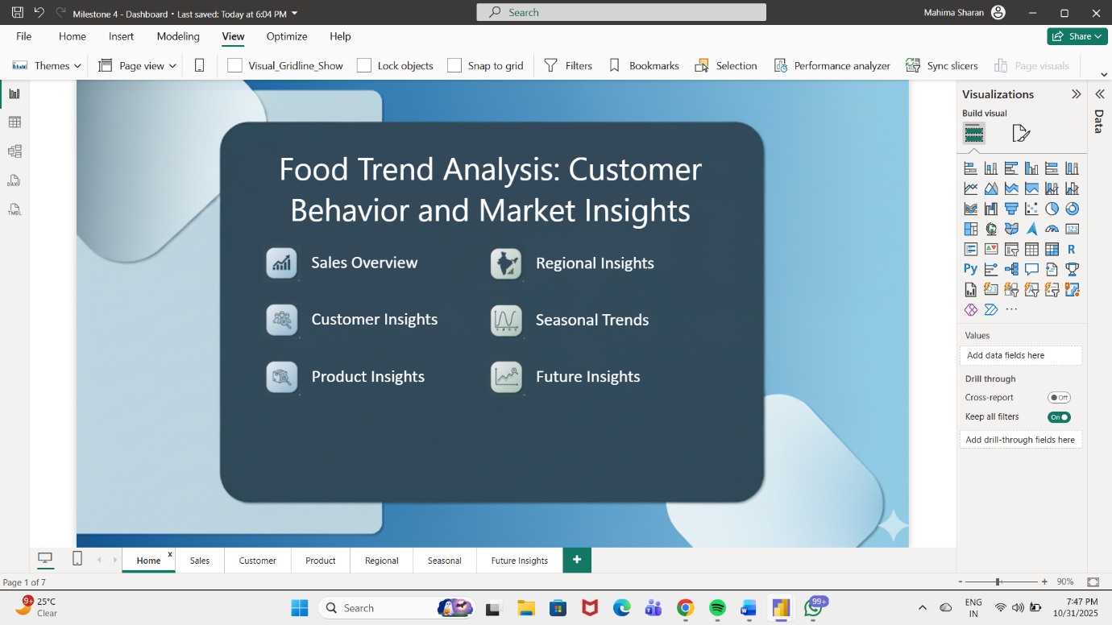

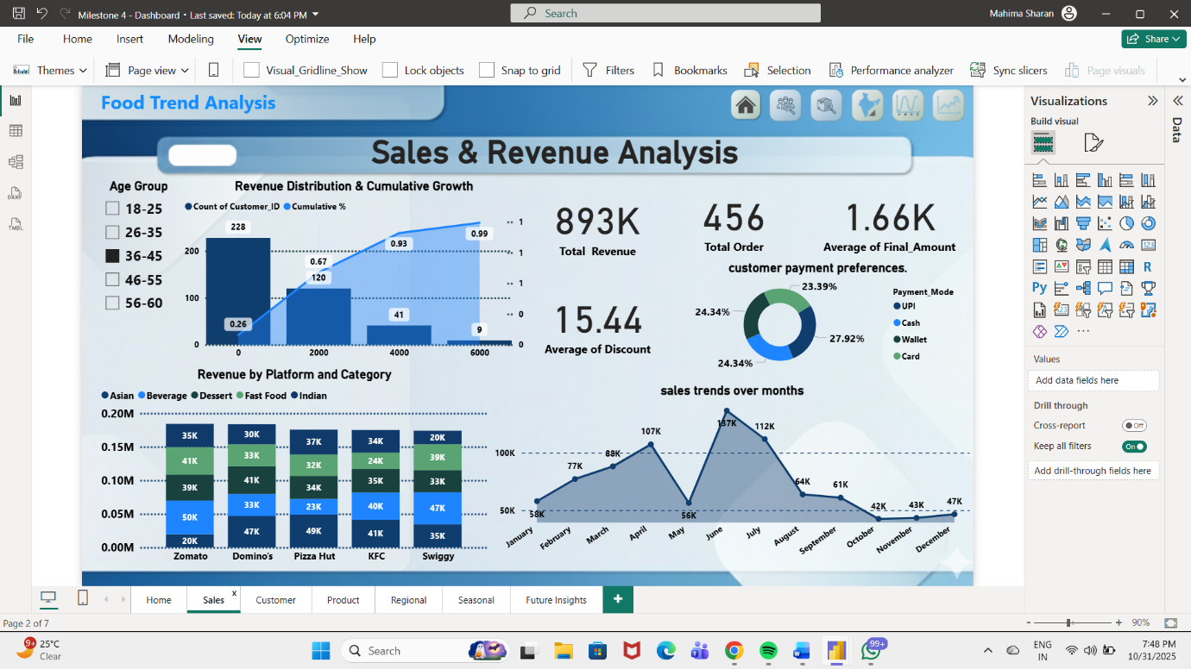

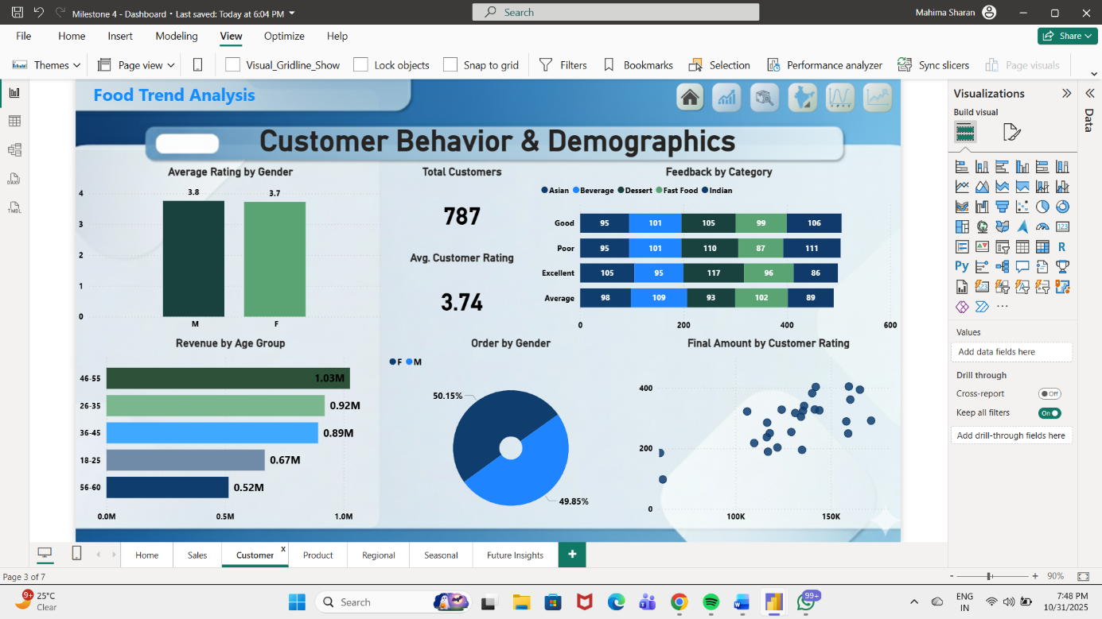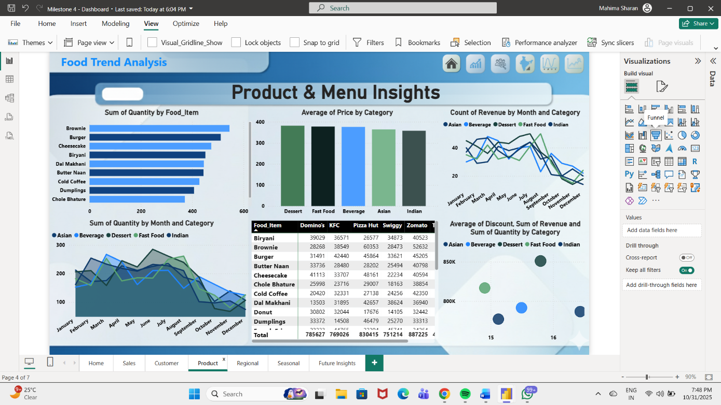

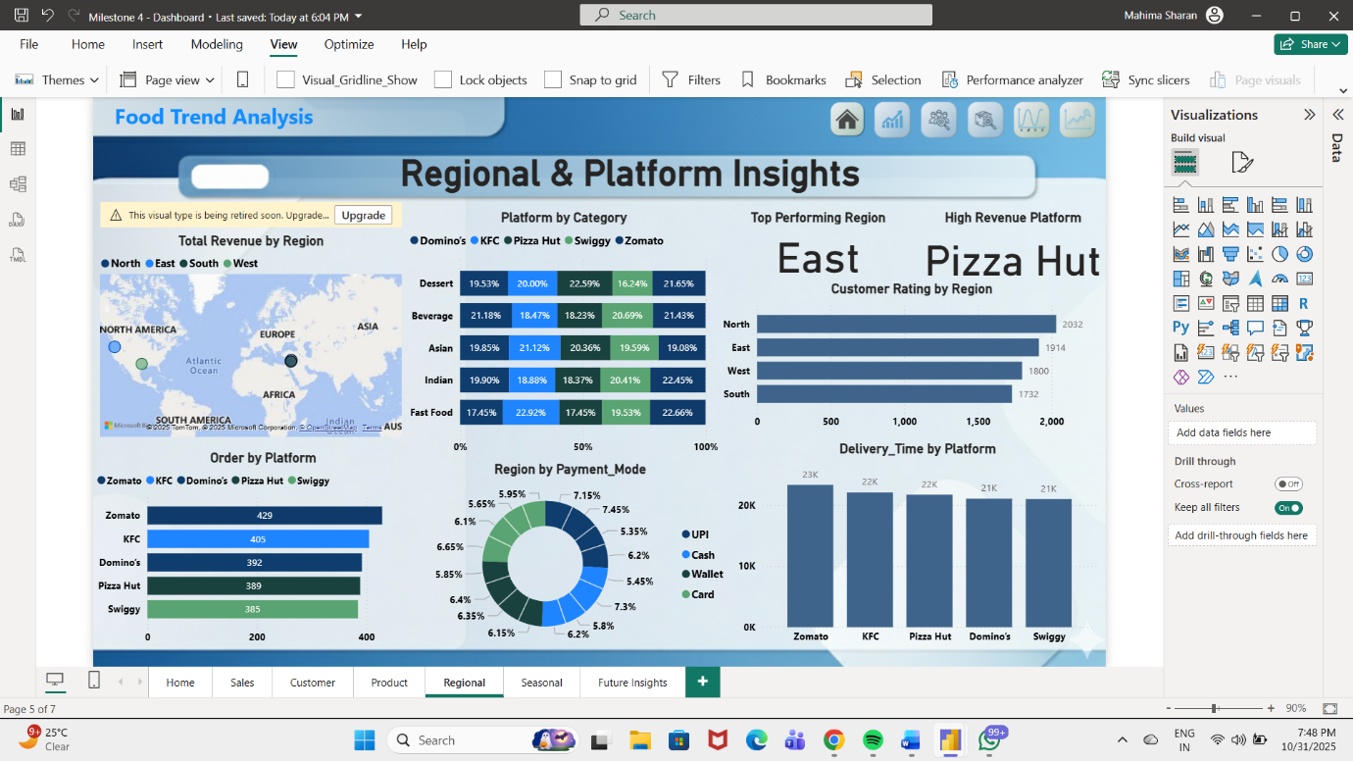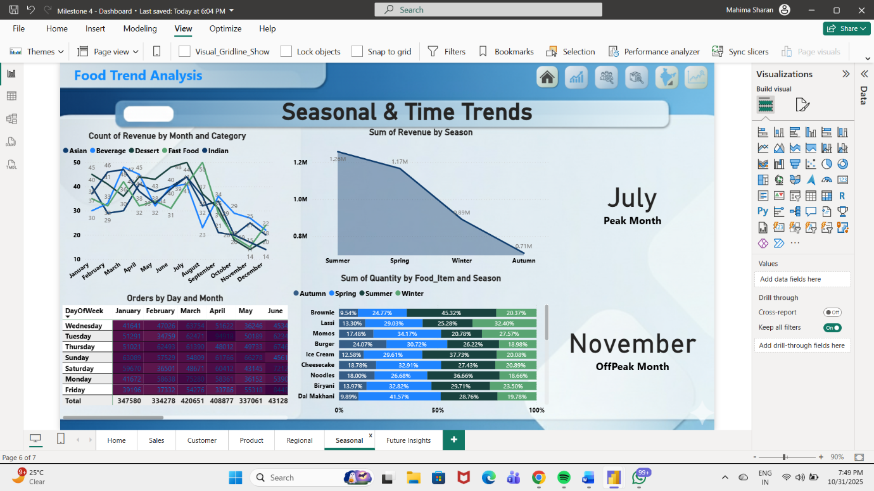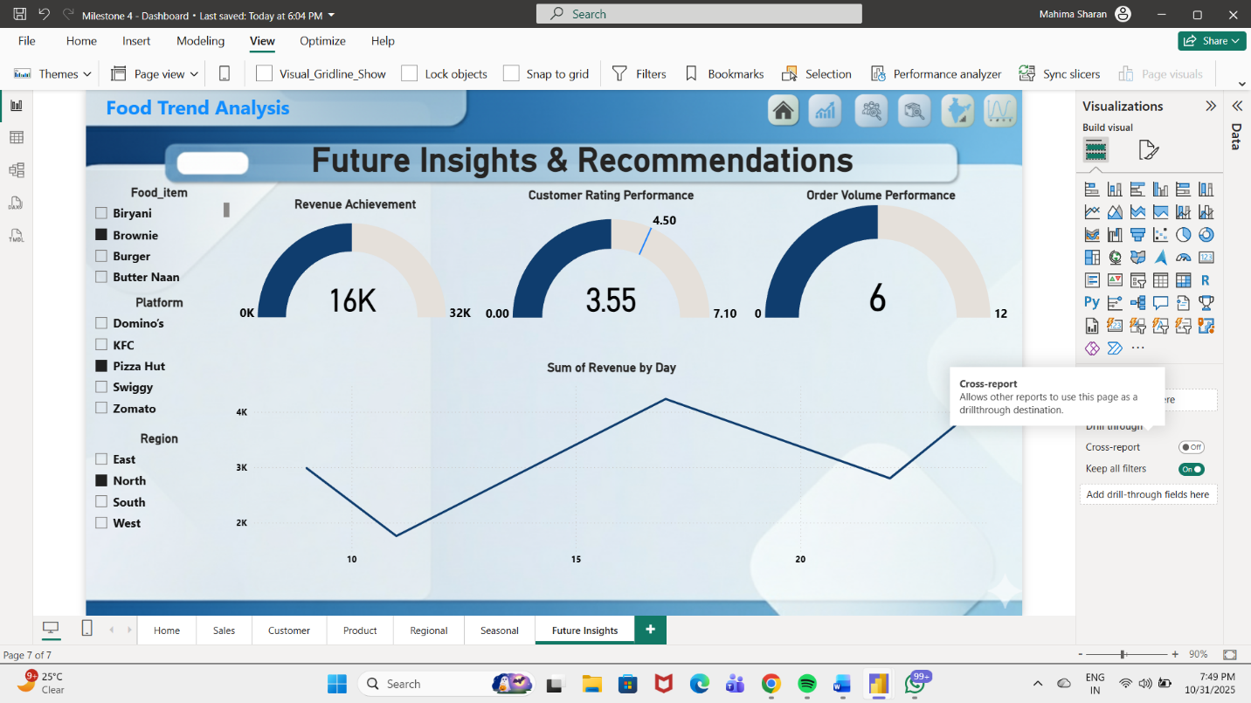

**TECHNOLOGY USED**

Microsoft Excel was used for the **initial preparation and cleaning** of the dataset before importing it into Power BI. The Excel sheet contained structured data on customer demographics, food preferences, order frequency, feedback ratings, and sustainability awareness.

The data preparation steps in Excel included:

* Removing missing or duplicate entries.
* Ensuring consistent formatting (for example, aligning gender values like “M” and “Male”).
* Using formulas for initial calculations (such as average spend per month).
* Saving the cleaned dataset in .xlsx format for seamless import into Power BI.

Excel played a key role as the **foundation for data accuracy** and provided an easy-to-manage source for Power BI to connect and analyze.

**Power Query Editor**

Power Query Editor is an integrated tool within Power BI that allows users to transform and clean datasets efficiently. It automates the process of shaping and structuring data before visualization.

In this project, Power Query was used to:

* Filter irrelevant rows and null values.
* Rename and reorder columns for consistency.
* Change data types (e.g., converting text columns to numerical or categorical values).
* Create custom columns for derived insights, such as categorizing spending levels as “Low,” “Medium,” or “High.”
* Combine multiple queries or tables (if required) into a single unified dataset.

The use of Power Query ensured that the dataset loaded into Power BI was clean, error-free, and ready for further processing.

**DAX (Data Analysis Expressions)**

DAX is a powerful formula language used in Power BI to create calculated columns, measures, and custom metrics. In this project, DAX was applied to perform advanced calculations that could not be achieved through direct data aggregation.

Some examples of DAX measures used in this dashboard include:

* **Average Spending** = AVERAGE(Customer[Monthly Spend])
* **Total Customers** = COUNT(Customer[Customer ID])
* **Average Feedback Score** = AVERAGE(Feedback[Rating])
* **Percentage Awareness** = DIVIDE(Count of “Yes” in Sustainability, Total Customers)

DAX enhanced the analytical depth of the dashboard, enabling it to provide real-time calculations and dynamic updates as filters or slicers were applied.

**Visualization and Design Tools**

The visual layer of the project relied heavily on Power BI’s visualization capabilities. The following visual elements were chosen to ensure clarity and engagement:

* **Cards:** For key performance indicators (KPIs) like Total Customers, Average Spend, and Average Rating.
* **Bar and Column Charts:** For spending patterns by gender, occupation, and cuisine type.
* **Pie Charts:** To represent proportions of food preference and sustainability awareness.
* **Slicers:** To allow users to interact with data based on gender, occupation, or age.
* **Donut Charts and Line Graphs:** For visual diversity and comparative insights.

The design followed a **minimalist and business-focused theme**, ensuring readability and visual balance while maintaining a professional appearance suitable for management review.

**System Requirements and Compatibility**

The project was developed using a system with the following configuration:

* Processor: Intel Core i5 / AMD equivalent
* RAM: 8 GB
* Operating System: Windows 10 or higher
* Software: Microsoft Excel, Microsoft Power BI Desktop (latest version)

This ensured smooth data processing and real-time visualization rendering.

**Summary of Technologies Used**

|  |  |
| --- | --- |
| Tool / Technology | Purpose |
| Microsoft Excel | Data cleaning and preparation |
| Power BI | Dashboard creation and visualization |
| Power Query | Data transformation and integration |
| DAX | Calculations and advanced analytics |
| Charts and Visual Tools | Data representation and storytelling |

**METHODOLOGY**

The methodology adopted for this project follows a systematic and structured approach to convert raw data into actionable insights through analytics and visualization. It combines elements of **data preprocessing, modelling, visualization, and interpretation** within a **Business Intelligence (BI) framework** using Microsoft Power BI as the primary tool.

The project methodology is divided into six key stages:

1. Data Collection
2. Data Preprocessing and Cleaning
3. Data Modelling and DAX Measure Creation
4. Dashboard Design and Visualization
5. Analysis and Insight Generation
6. Validation and Review

Each phase contributes to building a coherent and data-driven understanding of food trends and customer preferences in the F&B industry.

**Data Collection**

Data collection is the foundation of any analytics project. For this study, the data was **synthetically generated** to simulate realistic customer behavior patterns in the food and beverage market. The data represents key parameters such as customer demographics, order details, platforms used, payment methods, ratings, and product categories.

The dataset comprises **approximately 4,500–5,000 records and 20 attributes**, closely mirroring a real-world online food delivery system. The data was designed to emulate transactions from popular delivery platforms like **Swiggy, Zomato, and Uber Eats**, covering orders placed across various Indian cities and regions.

The data was prepared in **Microsoft Excel** and exported in **CSV format** to ensure compatibility with Power BI. Each record in the dataset represents a unique order transaction and includes details such as:

* Customer ID, Age, Gender, and Region
* Order Date, Time, and Platform Used
* Food Category and Item Ordered
* Quantity, Unit Price, and Total Amount
* Payment Mode, Delivery Time, and Rating

This comprehensive dataset forms the basis for all subsequent analyses, ensuring multidimensional insights into consumer behavior.

**Data Preprocessing and Cleaning**

Data preprocessing is a crucial step to ensure data accuracy, uniformity, and usability. Raw data often contains inconsistencies, missing values, or redundancies that can distort the results if not handled properly.

Using **Power BI’s Power Query Editor**, the dataset was cleaned and transformed through the following steps:

**a. Data Validation**

The first step involved examining the dataset for missing, duplicate, or invalid entries. Records with incomplete fields or logical inconsistencies (e.g., negative quantities or outlier prices) were corrected or removed to maintain data integrity.

**b. Standardization of Categorical Data**

Inconsistent text entries were standardized (for example, “swiggy” and “Swiggy” were unified). Uniform naming conventions were applied across platforms, categories, and payment modes.

**c. Derived and Calculated Columns**

New fields were added to enhance analytical capability:

* **Month** – Extracted from the order date for time-based analysis.
* **Day_of_Week** – Helps in studying weekday vs weekend patterns.
* **Season** – Categorized based on month ranges (Summer, Monsoon, Winter).
* **Revenue** – Calculated as *Quantity × Unit Price*.
* **Discounted Amount** – Derived from applied discounts.
* **Delivery Efficiency** – A calculated ratio between delivery time and rating.

**d. Data Type Formatting**

Numeric fields were properly formatted as decimals or integers, while date fields were standardized in “dd-mm-yyyy” format. Currency fields were formatted with consistent units.

**e. Data Validation and Loading**

After transformation, the dataset was validated to ensure referential consistency and was then **loaded into Power BI’s data model** for visualization and further analysis.

This stage ensured that the dataset was **clean, consistent, and analysis-ready**, forming a solid foundation for modeling and dashboard development.

**Data Modelling and DAX Measure Creation**

Once the data was cleaned, **data modelling** was performed to establish logical relationships among tables and prepare the analytical framework.

The **Star Schema** model was adopted — a widely used BI schema that optimizes performance for reporting and dashboards.  
The model consisted of:

* A **Fact Table** (Orders) containing quantitative data like revenue, quantity, delivery time, and ratings.
* **Dimension Tables** (Customer, Product, Date, Platform) that provided descriptive attributes for slicing and filtering the data.

**a. Establishing Relationships**

Relationships between tables were created using **unique keys** such as:

* *Customer_ID* linked with *Customer Table*
* *Order_ID* linked with *Order Details Table*
* *Platform* linked with *Platform Dimension Table*

This relational structure enabled efficient drill-down analysis and accurate aggregations in Power BI visuals.

**b. DAX Measures**

To support insightful KPIs and dynamic metrics, **DAX (Data Analysis Expressions)** formulas were used to create measures such as:

* **Total Revenue** = SUM(Orders[Total_Amount])
* **Average Rating** = AVERAGE(Orders[Rating])
* **Average Delivery Time** = AVERAGE(Orders[Delivery_Time])
* **Repeat Customer Ratio** = DIVIDE(COUNT(Customer[Repeat_Customer = “Yes”]), DISTINCTCOUNT(Customer[Customer_ID]))
* **Revenue by Platform** = CALCULATE(SUM(Orders[Total_Amount]), Orders[Platform])
* **Customer Satisfaction Index (CSI)** = AVERAGE(Orders[Rating]) / AVERAGE(Orders[Delivery_Time])

These DAX measures made the dashboard **interactive, dynamic, and responsive** to user selections and filters.

**Dashboard Design and Visualization**

The dashboard was designed in **six interactive pages**, each representing a different analytical aspect of the dataset. The design focused on creating an intuitive flow from general to specific insights:

1. **Home Page:** Overview of project purpose and key KPIs.
2. **Customer Demographics & Preferences:** Analysis by age, gender, and city.
3. **Product & Menu Insights:** Performance of food categories and items.
4. **Ordering Behavior & Satisfaction:** Analysis of frequency, time, and ratings.
5. **Regional & Platform Insights:** Revenue and orders segmented by location and platform.
6. **Seasonal & Time-Based Trends:** Monthly and seasonal sales analysis.
7. **Future Insights & Recommendations:** Forecasting and key takeaways.

**a. Visual Elements Used**

The following visuals were incorporated for clarity and engagement:

* **Bar and Column Charts** – For comparative metrics like revenue and platform performance.
* **Donut Charts** – For proportion-based visuals such as payment modes or order share.
* **Line and Area Charts** – For trends over time.
* **Maps** – For geographic analysis by city or region.
* **KPI Cards** – To highlight key metrics like “Total Orders,” “Revenue,” “Top Category,” etc.
* **Heatmaps** – For identifying peak ordering times.
* **Forecast Charts** – For predicting future order trends.

The visuals were color-coded for consistency, and slicers were added for interactivity, allowing users to filter by region, category, platform, or time period.

**b. User-Cantered Design Approach**

The dashboard layout followed principles of **clarity, consistency, and accessibility**:

* Each page included a title and short descriptive text to guide interpretation.
* Visuals were logically ordered — KPIs at the top, category-level details in the middle, and insights at the bottom.
* Filters were placed on the left panel for quick drill-downs.

This approach made the dashboard both **functional and presentation-ready**.

**Analysis and Insight Generation**

After visualization, the focus shifted to **interpreting insights** derived from the Power BI dashboard. The team analysed the visuals to answer critical business questions, such as:

* Which age and gender groups contribute most to revenue?
* Which categories are seasonally popular (e.g., desserts in summer)?
* Which regions perform best, and which require marketing focus?
* Which platforms (Swiggy/Zomato) dominate the order share?
* How do delivery time and customer ratings correlate?

The insights revealed trends like:

* **Fast food** being the most ordered category.
* **North Indian and metropolitan regions** showing higher average revenue.
* **Digital wallet and UPI payments** dominating urban orders.
* **Repeat customers** contributing significantly to total revenue.
* **Weekends and evenings** emerging as peak order periods.

These findings were compiled into actionable recommendations to guide F&B business strategies.

**Validation and Review**

The final stage of the methodology involved **testing, validation, and peer review** to ensure analytical accuracy and visual integrity.

* **Cross-verification** of measures was conducted by comparing manual Excel calculations with Power BI outputs.
* **Filter behavior** and drill-through navigation were tested to confirm logical accuracy.
* **Performance optimization** was achieved by reducing visual load and using DAX aggregations efficiently.
* The final dashboard was **reviewed collaboratively** by all team members to ensure consistency, clarity, and alignment with project goals.

Once validated, the dashboard was exported and shared for presentation and report documentation.

**KEY INSIGHTS**

The **Food Trend Analysis Dashboard** offers a multifaceted understanding of customer behavior, market patterns, and business performance within the Food & Beverage (F&B) sector. Using data from multiple platforms, regions, and food categories, the analysis uncovers critical insights that can shape future decision-making for businesses in this domain.

1. **Customer Preferences and Demand Trends:**  
   The analysis indicates that fast food and desserts are the most frequently ordered categories, driven by urban consumers seeking convenience and indulgence. Beverages maintain consistent demand across all seasons, highlighting their stability as a product segment.  
   Young adults (aged 18–35) represent the largest consumer group, showing a preference for online ordering through mobile-based platforms. The average order value is notably higher among professionals residing in metro cities.
2. **Product Performance and Pricing Patterns:**  
   The *Product & Menu Insights* section reveals that items such as burgers, brownies, and biryanis generate the highest revenue. Despite moderate pricing, these items show high order frequency, demonstrating a strong price-demand correlation. Premium categories such as Asian cuisine have fewer orders but higher margins, suggesting a niche yet profitable market.  
   The dashboard also identifies cross-category relationships—for instance, dessert orders often correlate with beverage purchases, indicating upselling potential.
3. **Regional and Platform Analysis:**  
   Regional insights highlight that the **North and West zones** dominate in total revenue contribution. Metro cities like **Delhi, Mumbai, and Bengaluru** show the highest order volumes, while smaller cities display growing engagement with wallet-based and online payments.  
   Among delivery platforms, **Swiggy and Zomato collectively account for nearly 80% of the total sales**, but the performance varies by region—Zomato leads in metro areas while Swiggy performs better in suburban zones.
4. **Temporal and Seasonal Trends:**  
   The time-based analysis shows clear ordering peaks during **weekends and evenings**, aligning with leisure and family dining behavior. Seasonal variation indicates that desserts and beverages are more popular in summer, while fast food and Indian cuisine dominate in winter months.  
   The line and area charts emphasize how promotional offers and festive seasons significantly influence purchase frequency and category preference.
5. **Operational and Marketing Insights:**  
   The dashboard highlights the impact of **discount strategies** on driving order volume. Average discounts between 10–15% show a strong positive effect on both order count and customer retention. Moreover, customer ratings correlate with repeat purchase frequency, emphasizing the importance of product quality and service consistency.

Overall, these insights provide a clear understanding of how **menu diversity, pricing, marketing, and customer experience** collectively shape business success in the competitive F&B marketplace.

**FUTURE INSIGHTS**

The *Future Insights* section leverages Power BI’s predictive capabilities and analytical reasoning to provide forward-looking observations and business recommendations that can optimize growth and profitability.

1. **Forecasting Customer Demand:**  
   Predictive analysis indicates a **10–12% projected growth** in beverage and fast-food categories during the next quarter. Seasonal forecasting suggests that promotional campaigns aligned with festivals or summer months can significantly boost order volumes.
2. **Strategic Recommendations:**
   * **Enhance Digital Engagement:** Introduce personalized offers through app notifications and loyalty programs to maintain customer retention.
   * **Diversify Menu Options:** Introduce healthy alternatives and fusion cuisines to appeal to emerging health-conscious consumers.
   * **Optimize Pricing and Discounts:** Implement region-specific dynamic pricing and limited-time discounts to maintain competitiveness.
   * **Focus on Underperforming Regions:** Launch targeted ad campaigns and delivery partnerships in low-revenue zones to balance market distribution.
   * **Sustainability Initiatives:** Highlight eco-friendly packaging and sustainable sourcing as key differentiators in urban markets.
3. **Platform Strategy and Operational Improvement:**  
   Swiggy and Zomato should collaborate with restaurant partners to improve delivery times and customer satisfaction ratings. Power BI’s forecasting charts reveal that platforms focusing on **faster delivery and superior app experience** show a direct impact on order recurrence and rating improvement.
4. **Performance Optimization through Data:**  
   Businesses can use the KPI and gauge metrics to set **target vs. actual performance** benchmarks for revenue, ratings, and delivery time. Integrating these insights with real-time tracking can enhance decision-making precision and responsiveness.

**CONCLUSION**

The project *“Food Trend Analysis: Customer Behavior and Market Insights”* has effectively demonstrated how data analytics and visualization tools like **Microsoft Power BI** can transform vast, unstructured datasets into meaningful, actionable business intelligence. Through the integration of multiple analytical perspectives—sales, customer, product, regional, seasonal, and future forecasting this dashboard provides a comprehensive understanding of how various factors influence consumer behavior and overall business performance within the **Food & Beverage (F&B)** industry.

This analysis emphasizes that data-driven insights play a crucial role in modern decision-making. By examining **customer demographics, purchasing frequency, category preferences, pricing patterns, and temporal trends**, the project uncovers the underlying forces shaping consumer choices. Businesses can leverage these insights to optimize their product offerings, marketing strategies, and operational efficiency.

The **Sales Overview** page provided a foundational understanding of revenue, orders, and average ratings—acting as a central performance snapshot. It enabled quick identification of business strengths, seasonal fluctuations, and areas requiring attention.  
The **Customer Insights** page highlighted the behavioral segmentation of consumers, identifying age groups, order frequencies, preferred cuisines, and payment preferences information that is invaluable for targeted marketing and customer retention.  
The **Product Insights** dashboard offered a deeper look into menu performance, revealing best-selling items, category profitability, and pricing impacts. This helped identify both high-margin and high-demand food items, guiding product strategy and promotions.  
The **Regional Insights** section explored geographic diversity in customer orders, platform preferences (Swiggy, Zomato, etc.), and payment trends, emphasizing the importance of region-specific business strategies.  
The **Seasonal & Time-Based Trends** dashboard revealed how external factors—such as festivals, weekends, and weather conditions—affect ordering behavior, helping restaurants and platforms plan inventory and offers efficiently.  
Finally, the **Future Insights** page extended the dashboard’s analytical power through predictive modeling and strategic recommendations. Using Power BI’s forecasting tools, it projected demand trends, revenue growth potential, and offered actionable suggestions for business improvement.

From a technical perspective, the project demonstrates the **methodical application of data analytics principles**—data cleaning, transformation, modeling, and visualization culminating in a well-structured and interactive Power BI report. Each page of the dashboard complements the others, creating a holistic analytical environment where end-users can explore insights dynamically through slicers, filters, and KPIs. The project also highlights the importance of intuitive visual storytelling, where charts, graphs, and KPIs collectively communicate complex data in a visually appealing and accessible format.

The insights derived have direct business implications. For instance, the discovery that **fast food and dessert categories dominate orders**, while **Swiggy and Zomato collectively drive nearly 80% of total revenue**, provides clear guidance for platform-specific strategies. Similarly, recognizing that **wallet and digital payments are more prevalent in urban areas** informs future digital partnership and payment innovation plans. The consistent performance of beverages across all seasons also indicates a stable product category that can be further leveraged for cross-selling opportunities.

Moreover, the seasonal analysis suggests that customer engagement increases during weekends and festive periods, highlighting opportunities for **targeted marketing campaigns** and **timely promotional offers**. The findings from regional and product-based insights can also help businesses allocate budgets more effectively—focusing on high-performing regions and optimizing resource utilization in underperforming areas.

Beyond immediate business use, the project showcases how **data analytics fosters innovation and strategic planning**. By integrating historical data with forecasting, businesses can anticipate customer needs, align operational capacity, and maintain a competitive edge. This future-oriented approach transforms the dashboard from a static analytical tool into a **strategic decision-support system** capable of driving sustainable growth.

Overall, the project reinforces the value of **Power BI as a powerful platform for data-driven storytelling**, bridging the gap between data and actionable intelligence. It equips stakeholders ranging from restaurant managers to marketing teams with a unified, real-time view of business performance and consumer behavior. The dashboard’s interactive nature enables continuous exploration, helping businesses not just react to trends, but proactively shape them.

In conclusion, this project successfully meets its objectives by providing a comprehensive, visually compelling, and insight-rich analysis of food industry dynamics. It demonstrates how technology and analytics can redefine operational strategies, enhance customer experience, and enable businesses to thrive in an increasingly data-centric marketplace. The *Food Trend Analysis Dashboard* thus stands as a model for modern analytics-based business decision-making-an integration of data science, visualization, and strategic intelligence designed to drive measurable impact and long-term growth.